
DIGITAL LITERACY PROJECT

NAME: VIYA HARPALANI
REGISTRATION NUMBER: 25BHI10089
BRANCH: CSE (HEALTH INFORMATICS) 1st year
COURSE CODE: CSE-0001
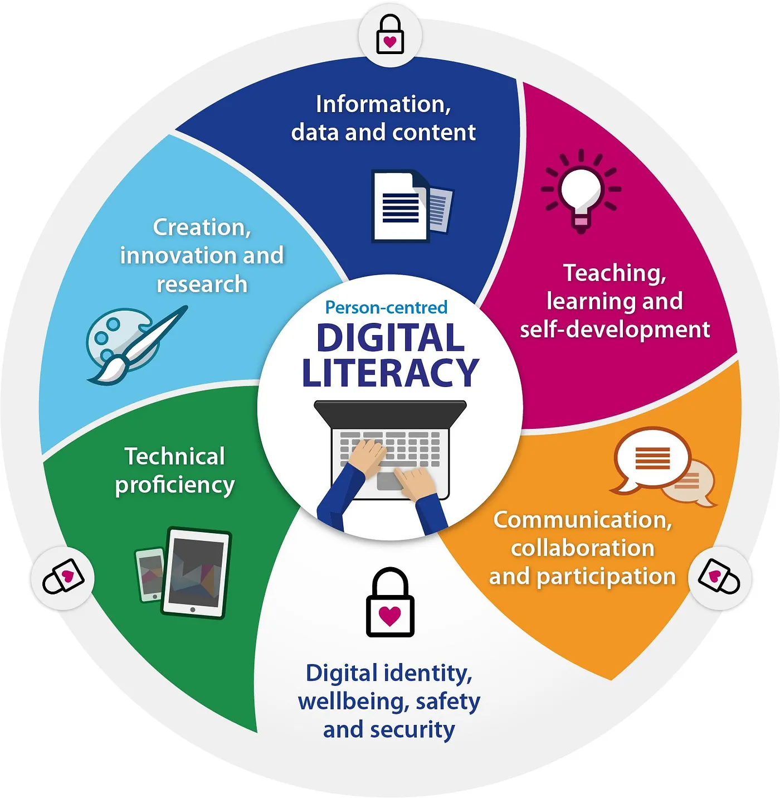
DATE: 28/03/2026

INTRODUCTION

In today’s rapidly evolving digital world, digital literacy has become an essential skill for students. As a Student Digital Ambassador, this project was undertaken to promote awareness about the effective, ethical, and safe use of digital technologies.
This project focuses on developing a Digital Literacy Portfolio, which includes understanding digital tools, building a professional online presence, practicing proper communication, and being aware of cyber threats.
The project is divided into five important tasks:
Digital awareness creation
Portfolio development
Coding and collaboration tools
Email etiquette
Cybercrime awareness
Through this project, I have gained practical knowledge and developed skills that are crucial for academic growth and future professional success.
Task 1: Digital Literacy Awareness Infographic
For this task, I created a digital infographic using Canva, which helped present information in a visually attractive and organized manner.
The infographic focused on three main areas:
1. Meaning of Digital Literacy
Digital literacy refers to the ability to effectively use digital tools, platforms, and technologies in a safe and responsible way.
2. Useful Digital Tools
Google Docs – for writing and collaboration
Microsoft Word – for document creation
GitHub – for coding and project sharing
3. Safe Internet Practices
Use strong and unique passwords
Avoid clicking suspicious links
Protect personal information
Enable two-factor authentication
Learning Outcome:
This task improved my ability to present information clearly and design visually appealing educational content.
Task 2: Student Digital Portfolio
In this task, I created and improved my professional profiles on various platforms:
1. GitHub
GitHub is a platform used to store and manage coding projects.
I uploaded my project to showcase my work:
GitHub Link:
https://github.com/viyah2104-art/Digital-literacy-project⁠�
Future Plan:
Upload more projects
Improve coding skills
Build a strong portfolio
2. LinkedIn
LinkedIn helps in professional networking.
I added my educational details and will use it to:
Connect with professionals
Explore internships
Share achievements
3. ResearchGate
This platform is useful for academic learning and research.
I plan to use it to:
Read research papers
Gain subject knowledge
Share future research work
Learning Outcome:
I understood the importance of maintaining a professional digital identity.
Task 3: Coding & Collaboration Platforms
In this task, I explored both coding and collaboration tools.
HackerRank (Coding Platform)
Solved a beginner problem: “Solve Me First”
Created a Python function to add two numbers
Learned:
Input and output handling
Functions
Basic programming logic
Google Workspace (Collaboration Tool)
Created a quiz using Google Forms
Included:
Multiple-choice questions
Short-answer questions
Linked responses to Google Sheets
Learning Outcome:
Improved basic coding skills
Learned how to collect and analyze data
Understood teamwork and collaboration tools
Task 4: Professional Email & Etiquette Guide
During my Class 12 project, I experienced a problem due to poor digital communication.
Situation:
Important instructions were shared late at night in a WhatsApp group, which I had muted.
Problem:
Missed important update
Completed work in wrong format
Faced confusion and stress
Solution & Learning:
Check important messages regularly
Keep notifications on for academic groups
Communicate clearly and professionally
Key Takeaway:
Digital etiquette and timely communication are essential to avoid misunderstandings.
Task 5: Cybercrime Awareness
This task helped me understand the risks associated with online activities.
Common Cyber Threats:
Phishing scams
Fake internship offers
Fraudulent UPI requests
Malicious links and QR codes
Important Observations:
Small mistakes can lead to serious financial loss
Students are common targets of scams
Quick reporting is necessary to prevent damage
Preventive Measures:
Never share OTP or PIN
Verify links before clicking
Use strong passwords
Enable two-factor authentication
Learning Outcome:
I became more aware and cautious while using digital platforms.
Conclusion
The Digital Literacy Project has been a highly informative and practical experience. It has helped me understand the importance of using digital tools efficiently, responsibly, and safely.
Through this project, I developed skills such as:
Professional communication
Digital portfolio building
Cyber safety awareness
This experience has increased my confidence and prepared me for future academic and professional challenges in a digital environment.
REFERENCES
canva.com
github.com
linkedin.com
hackerrank.com
codechef.com
forms.google.com
cybercrime.gov.in
Cyber Crime Helpline: 1930

